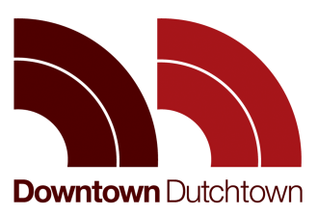

November 27, 2018
Letter in Support The Bluffs on Broadway

City of St. Louis
Excise Division
City Hall, 1200 Market, Room 418

To whom it may concern,
Downtown Dutchtown (formally Downtown Dutchtown Business Association) offers its support of Mark Widmann and The Bluffs on Broadway for a liquor license and dancehall renewal. Mr. Widmann and The Bluffs on Broadway are an invaluable member of the Dutchtown community. Mr. Widmann runs a wonderful business at The Bluffs on Broadway with no known complaints from the community. Moreover, Mr. Widmann has contributed in numerous ways to invest in the community including facilitating fundraisers for DT2. Any loss to his ability to operate The Bluffs on Broadway would be a substantial loss to the community.
Thank you for your consideration and please contact me with any questions at nate@dt2stl.org.
Best,

Nate Lindsey, DT2 President

CC:
Mark Widmann

