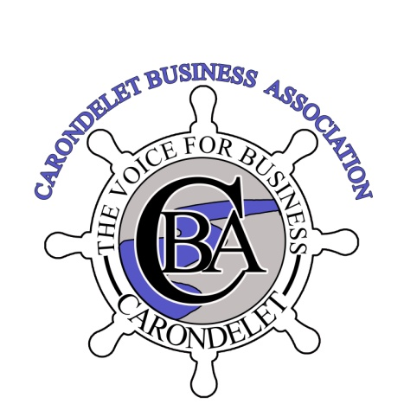

November 26, 2018

To whom it may concern;

RE: The Bluffs on Broadway

Mark Widmann, in addition to being a member of our organization; runs an upstanding reputable event center in a very professional manner.

We heartily endorse and continue to support him and would hope that his liquor license and "dance hall" license will be renewed. Mark has made a substantial investment in our community and is an asset for all of us to be proud of.

We appreciate you allowing him to continue to do so!!

Additionally, I own a house just a block south of his property and would personally sign a petition for the same.

Sincerely,

Jaymes Dearing
Acting Interim & past President

www.CBAstlouis.com

6410 Michigan St. Louis, MO 63111 314 351-4099

